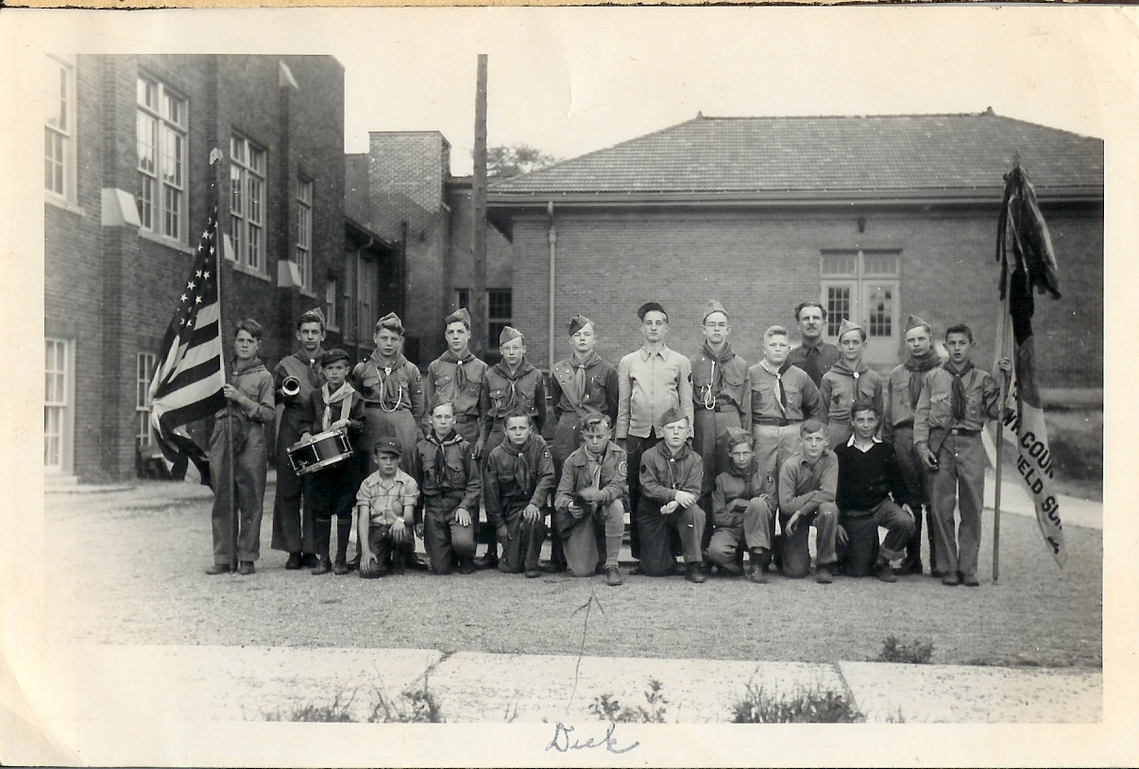

Whitfield School Boy Scout Troop 27 – 1945 or 46
Front Row: Ray Dahlgren, Bob Jones, Herbie Ward, Dick Prue, Clair Silas, ?, Ron Manning, Rich Leitner
Back Row: Jerry Webster, Bob Haney, Earl Kreps, Ron Weaver, Chuck Wixom, Joe Leavy, Art Fritz, Chuck Koella, Tom McHugh, Herb Terrick Scout Master; Jim McLean, Ray Schruba, Paul Bochnig
Identified by Joe Leavy and Ray Dahlgren

Scouting was a big thing then. There was no Lakeland Athletics. The troop went on overnight camping trips once a month. They would sleep in tents and cook their own food. Everyone was in Boy Scouts. Ray Dahlgren.

