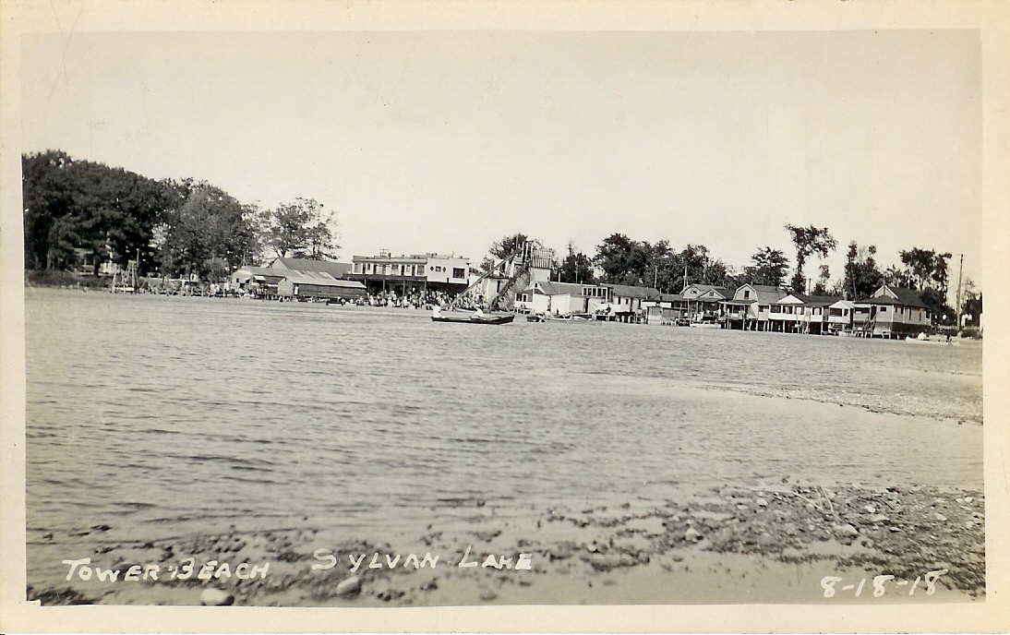

Tower Beach

Sylvan Lake, Oakland Co., Mich. August 18, 1918

When the Detroit and United Railway plotted its course through the Sylvan Lake area on its route between Pontiac and Detroit, local residents became more interested in the development of recreation. An amusement park called Tower Beach and a picnic spot called Happy Home in Voorheis Grove were developed. It became the “in” thing to pack up the whole family, a large picnic basket, mount the trolley car and spend the entire day fishing, swimming, bathing and enjoying their picnic lunch. The big day was climaxed by the trolley car ride back home.
Oakland County Book of History,
The Sesqui-Centennial Publication 1820 – 1970; Arthur A. Hagman, Editor

October 7, 1931 Tower Beach Bridge

Resolved by Trustee Cox, supported by Trustee Mitchell: that the Clerk be authorized to correspond with the proper authorities of the Michigan Eastern Railways in regard to getting information relative to securing the Tower Beach Bridge for the Village.
Yeas: Sener, Cox, Mitchell, Woodbridge Resolution adopted.

The late Daisy Worley remembered that the late Roy Durfee owned concessions at Tower Beach at the north end of the Lake. At the beach, people could rent a little cabin in which to change into their rented swimming suits. Boats were available for fishing. Visitors entertained themselves by taking a board to the top of the tall slide and sliding down into the lake. There were numerous injuries as the boards and people collided.

