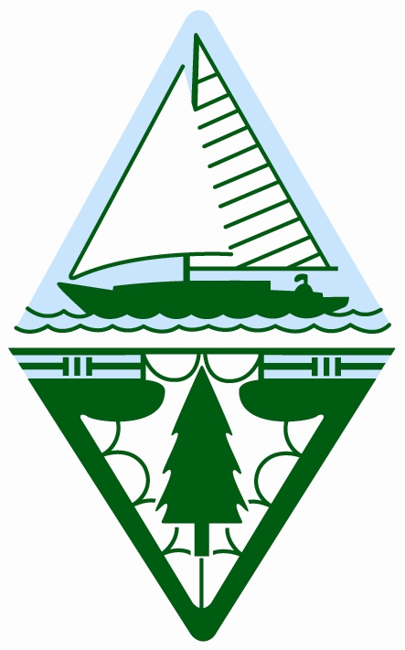

Orchard Lake Museum
3951 Orchard Lake Road
Orchard Lake, MI 48323

248.757.2451
www.gwbhs.com
501(c)(3) organization

2011-12 officers
President
Buzz Brown

Vice President
Cara Kazanowski

Recording Secretary
Gina Gregory

Corresponding Secretary
Betty Bradbury

Treasurer
Susan Williams

Directors
Carol Fink
William McIsaac
Helen Jane Peters



