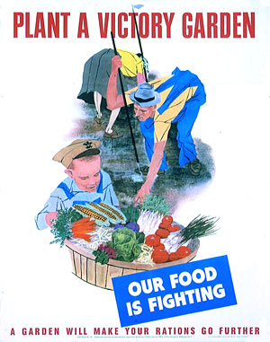

World War II victory garden poster, Office of War Information, 1943

Victory Gardens
Victory Gardens were planted on Central Avenue and Woodland Street during the 1940’s. The late Mrs. Josephine James and the late Mrs. Georgia Cleveland remember the Sylvan Lake Victory Gardens.
April 5, 1944 Sylvan Lake Village Council Minutes
Sylvan Lake President Jarvis commented on the Garden Club’s program for the 1944 Victory gardens outlined in their recent letter distributed to all Villagers and expressed appreciation for a real civic accomplishment.
As part of the war effort, the government rationed foods like sugar, butter, milk, cheese, eggs, coffee, meat and canned goods. Labor and transportation shortages made it hard to harvest and move fruits and vegetables to market. So, the government turned to its citizens and encouraged them to plant "Victory Gardens." Nearly 20 million Americans answered the call. Neighbors pooled their resources, planted different kinds of foods and formed cooperatives, all in the name of patriotism.

With the current economic times, perhaps it’s time to plant Victory Gardens again.
~~~~~~~~~~~
Daniel Whitfield School Reunion
The reunion will take place on Sunday, August 2nd, 2009, from 1:00 p.m. to 4:00 p.m. at the Sylvan Lake Community Center. If you or your children attended Whitfield School, we invite you to attend and please invite your classmates. Please bring photos from Whitfield/Sylvan Lake. Contact Helen Jane Peters for more information.
Pontiac High School Alumni Party
The party will be on Saturday, August 1st, 2009, beginning at 5:00 p.m. Saturday evening. The location is at the Pontiac/Waterford Elks Club on Scott Lake Road in Waterford.

